2021-2022 NSCAS Roster Review Process in ADVISER Validation

Table of Contents
Roster Population for Each Assessment 2
Instructions to run NSCAS Assessment Roster Reports in ADVISER Validation 2
SPED and FRL Access in ADVISER Validation 3
Alternate Assessment Flag in ADVISER Validation 4
Exempt (home) School Students 4
ADVISER Validation Error Codes 5
Expected Graduation Year (Cohort Year) 6

Roster Population for Each Assessment
NSCAS Growth (NWEA) includes students:
- Grades 03 – 08
- FTE of 51% or more

NSCAS Alternate (DRC) includes students:
- Alternate Assessment MUST be checked YES within the Special Education Information of the individual student’s record in ADVISER.
- Grades 03 – 08 and high school third-year cohort (Cohort Year = 2023)
- FTE of 51% or more

NSCAS ACT (ACT) includes students:
- In their high school third-year cohort level (Cohort Year = 2023)
- FTE of 51% or more

Instructions to run NSCAS Assessment Roster Reports in ADVISER Validation

Your district’s data steward can assist you in running these reports if you do not have access to ADVISER Validation.
- Log into the NDE Portal: https://portal.education.ne.gov/site/DesktopDefault.aspx
- Click on the Student & Staff (NSSRS) tab
- Click on ADVISER Validation
- Enter your district and appropriate school year (2021-2022) and click “Select”
- Click on Students under VERIFICATION REPORTS
- Click on Assessment
- Click on the “NSCAS Growth Roster” or “NSCAS ACT/Alternate Rosters” (should be BLUE with correct ADVISER rights)
- The NSCAS Growth Roster report may take a few minutes to populate, depending on your district student count. (See screenshot on next page.)
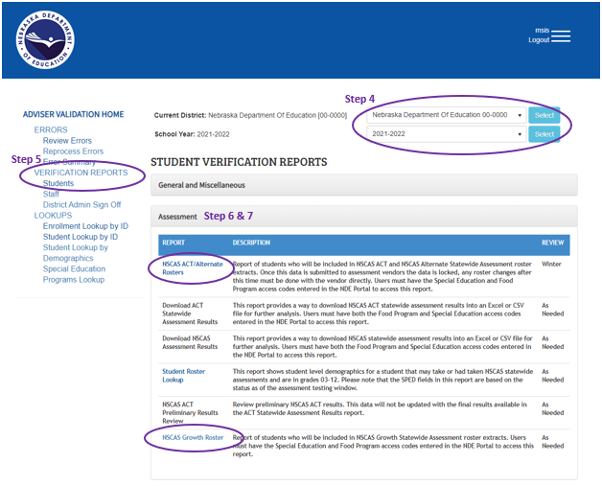
- For the NSCAS ACT/Alternate Rosters report only, select the appropriate test in the Assessment dropdown for the test roster you want to review and click View Report.

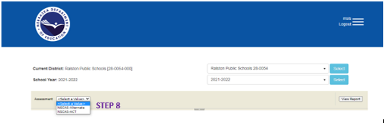
- A list of students will appear after clicking View Report. You can review it and/or click on the Export icon and export your list into Excel.

SPED and FRL Access in ADVISER Validation
NDE has increased their data security in ADVISER Validation. If you are unable to run the roster reports, it may be due to lack of access to SPED and FRL data. You will need to ask your district’s Admin (Superintendent) for an access code for each category of data (SPED and FRL) in addition to your existing ADVISER Validation access code to run the roster labels. Below are the steps to obtain and activate the SPED and FRL codes:
DISTRICT ADMIN:
- Once logged into the NDE Portal click on the District Admin tab
- Choose Collection “ADVISER Validation”
- A table will appear, copy the code for Program-Food Program (FRL) and the code for Program-Special Education (SPED) and send these codes to the DAC.
DAC:
- Once logged into the NDE Portal click on the Student & Staff (NSSRS) tab
- Click on Add/Remove for ADVISER Validation
- Paste the codes (one at a time) in the Activation Code box & click

Alternate Assessment Flag in ADVISER Validation
How-To video for coding Alternate Assessment field in SRS: https://youtu.be/O5xxgdf_7pg
Snip-it of where this field is with a student’s SPED record in ADVISER:
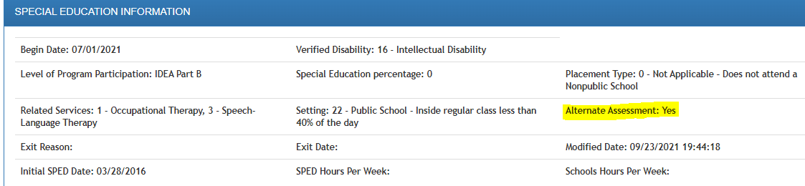
SRS Helpdesk information:
srshelp@esucc.org
402-597-4994

Exempt (home) School Students

Your Superintendent should have access to the Exempt Schools – School District Report within the Data Collections area of the NDE portal for the status of submissions of the exempt (home) school students. You should also refer to the Status Description/Coding for Enrollment sheet that provides data coding guidelines; housed in the same area as the report.

Once you see a “submitted” or “pending” status on the report the district can move forward with a 205-enrollment code in their SIS/SRS/ADVISER. With the 205 code and an effective date in ADVISER, this will remove the students from the assessment rosters.

ADVISER Validation Error Codes

District ADVISER Data Stewards should be able to review the following ADVISER error codes and know how to make the needed edits in your district SIS/SRS for the corrections to be published into ADVISER. Corrections to these errors will help make your roster file data more accurate.

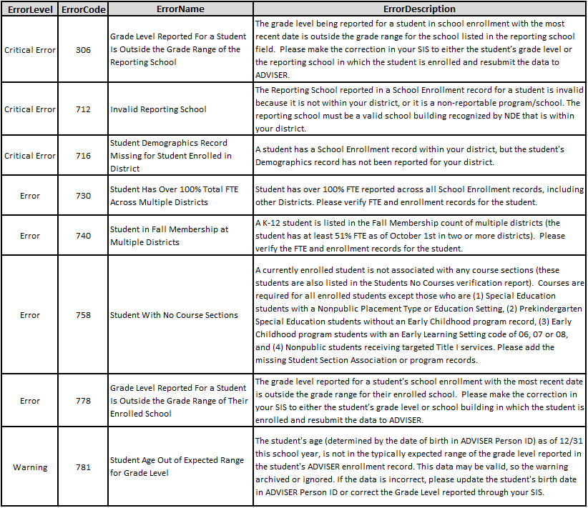

Error 743 – No Race Reported for Student

Expected Graduation Year (Cohort Year)
Students In their high school third-year cohort level (Cohort Year = 2023) are expected to participate in the NSCAS ACT or the NSCAS Alternate Assessment.

Guidance for Graduation Cohort Version 5.0.0 (NDE is working on updating this guide.)
Snip-it from the ADVISER Data Elements 2021-2022 Version 6.0
